Ranoa, Julius

CSC 121 001 Computer Science I

September 7, 2017 Thursday

**Homework on Chapter 4.**

**Part I – Review Questions and Exercises. Qn. 11 – 20, 22 – 24.**

1. The AND logical operator works best when testing a number to determine if it is within a range.
2. The OR logical operator works best when testing a number to determine if it outside a range.
3. A variable with LOCAL or BLOCK scope is only visible when the program is executing in the block containing the variable’s definitions.
4. The expression that is tested by a switch statement must have a(n) INTEGER value.  
   The data types, CHAR and ENUM, also have integer values so they’re valid too.
5. A program will “fall through” to the following case section if it is missing the BREAK statement.
6. What value will be stored in the variable t after each of the following statements executes?
   1. t = (12 > 1); True
   2. t = (2 < 0); False
   3. t = (5 == (3 * 2)); False
   4. t = (5 == 5); True
7. Write an if statement that assigns 100 to x when y is equal to 0.

if (y == 0) x = 100;

1. Write an if/else statement that assigns 0 to x when y is equal to 10. Otherwise it should assign 1 to x.

if (y == 10) x = 0;

else x = 1;

1. Write an if/else statement that prints “Excellent” when score is 90 or higher, “Good” when score is between 80 and 89, and “Try Harder” when score is less than 80.

if (score >= 90) cout << “Excellent”;

else if (score >= 80) cout << “Good”;

else cout << “Try Harder”;

// assuming score is declared int.

1. Write an if statement that sets the variable hours to 10 when the flag variable minimum is set to true.

if (minimum) hours = 10;

1. Convert the following if/else statements into a switch statement:

if (choice == 1)

cout << fixed << showpoint << setprecision(2);

else if ((choice == 2) || (choice == 3))

cout << fixed << showpoint << setprecision(4);

else if (choice == 4)

cout << fixed << showpoint << setprecision(6);

else

cout << fixed << showpoint << setprecision(8);

switch (choice) {

case 1:

cout << fixed << showpoint << setprecision(2);

break;

case 2:

case 3:

cout << fixed << showpoint << setprecision(4);

break;

case 4:

cout << fixed << showpoint << setprecision(6);

break;

default:

cout << fixed << showpoint << setprecision(8);

}

1. Assume the variables x = 5, y = 6, and z = 8. Indicate if each of the following conditions is true or false:
   1. (x == 5) || (y > 3) True
   2. (7 <= x) && (z > 4) False
   3. (2 != y) && (z != 4) True
2. Assume the variables x = 5, y = 6, and z = 8. Indicate each of the following conditions is true or false.
   1. (x >= 0) || (x <= y) True
   2. (z – y) > y False
   3. !((z – y) > x) True

**Part II – Programming Challenge 11. Geometry Calculator**

In submission: C++ Source Code in Three (3) Files

Screenshots of Runtime

1. **main.cpp**



1. **GeometryCalculator.h**
2. **GeometryCalculator.cpp**

*\* GeometryCalculator.cpp continued next page*

*\* GeometryCalculator.cpp continued next page*

*\* GeometryCalculator.cpp continued next page*



**Screenshots of Runtime.**

Attached: 5 Images.

**Image 1**

Calculating Area of a Circle

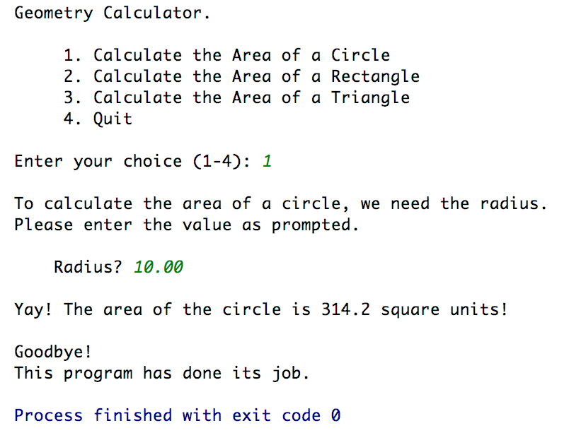

**Image 2**Calculating Area of a Rectangle

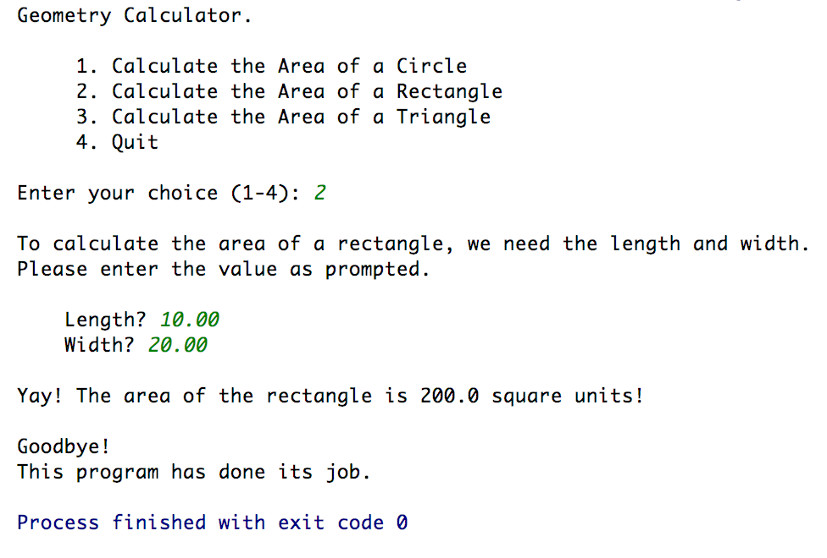

**Image 3**

Calculating Area of a Triangle

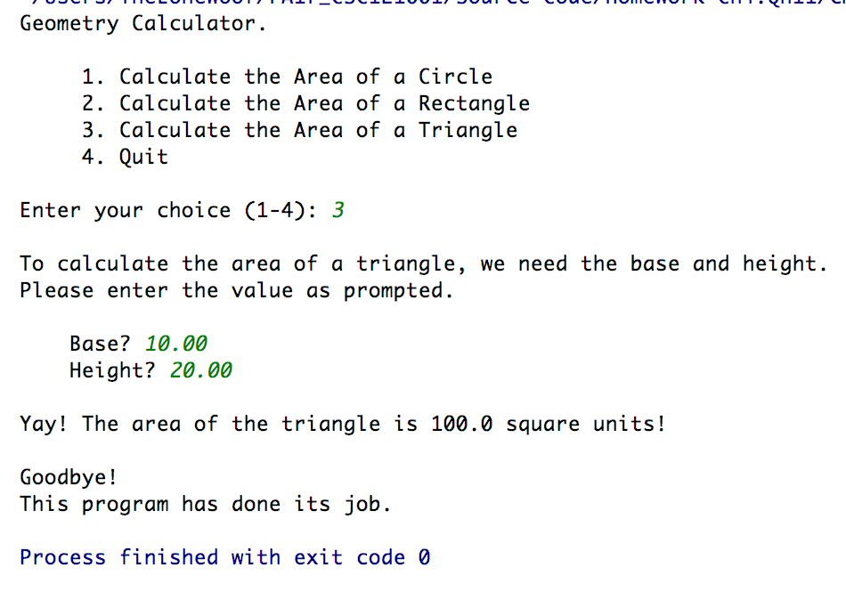

**Image 4**

Quitting the Program

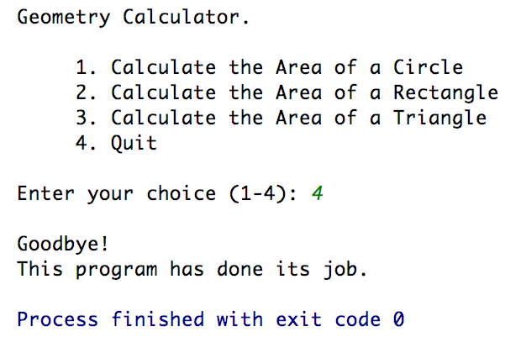

**Image 5**

Entering an invalid input

